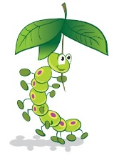
CATERPILLARS PRE-SCHOOL (SUSSEX) LIMITED

21. NO SMOKING
We comply with health and safety regulations and the Welfare Requirements of the EYFS in making our setting a no-smoking environment- both indoor and outdoor.
Procedures
  - All staff, parents and volunteers are made aware of our no-smoking policy.
  - We display no-smoking signs.
  - The no-smoking policy is stated in our information brochure for parents.
  - We actively encourage no-smoking by having information for parents and staff about where to get help to stop smoking if they are seeking this information.
  - Staff who smoke do not do so during working hours. Unless on a break and off the premises.
  - Staff who smoke during their break make every effort to reduce the effect of the odour and lingering effects of passive smoking for children and colleagues.

Legal framework
- The Smoke-free ( Premises and Enforcement) Regulations 2006
- The Smoke-free (Signs) Regulations 2012

This policy was adopted by the Manager of Caterpillars Pre-school on 4th April, 2023
…………………………………………………………
Name of signatory: Catherine Clark Role of signatory: Manager

